2. PROJECT MANAGEMENT

2.1 FEASIBILITY STUDY

Various types of Feasibility study are identified as under:

    - Technical Feasibility

The technical Feasibility test involves questions like

- Is the current Computer’s configuration and system technology adequate for Usage?
- Is the selected technique sufficient for future enhancements?
- Are the manpower and resources available sufficient for development and maintenance?
All these feasibility constraints are satisfied.

    - Operational Feasibility

The users of the system should be able to operate it easily. This demands good user interface. The system we developed can be operated using any audio/video remote control widely in use these days by any common man. A reference to the User Manual is required for the user to learn about the modes of operation. Hence there is a very little possibility that the user would resist using the system.

    - Economic Feasibility

The questions put forward in economic feasibility are:

- Are there sufficient cost benefits in creating the system?
- Are the costs of implementation of current system so great that the task of project development is required?

This feasibility study measures the cost effectiveness of project. It takes into consideration cost and benefit.

- Hardware-Software Cost

This feasibility is of paramount importance in development of any system. The system requires C compiler softwares which are easily available on the internet for free. The only cost under concern is the hardware cost of the system which is very much affordable.

- Maintenance Cost

This includes the hardware maintenance cost of the system which is not an issue unless there is any damage in the system.

    - Time Schedule Feasibility

The system with its major specifications is feasible to implement in the allotted time.

  - PROJECT PLANNING

2.2.1 Project Development Approach and Justification

The requirements of the system keeping the user in mind are first analyzed, revised, validated and approved by the users. The development commences after the approval phase. The system designer and developer will try to adhere to the requirements mentioned above in order to develop the required system.
The system requires development of both hardware and software. Thus the reversible waterfall model is used for developing our system. The development of system will include study of requirement analysis, feasibility study, planning entire design. The testing will include the unit testing after every phase is completed and then integration testing and System testing. If any change in prior stage this model will enable us to review the system.

2.2.2 Project Plan

The Project planning includes understanding of the requirements completely and abstract designing of entire system. The entire design cannot be made at once so the system is divided into subsystems and modules and each module is to be designed and implemented one by one.
The first task is the feasibility study in planning of any project according to the requirement specification. If the project is feasible then we must move on to the designing and developing system.
The premiere task would be study of requirement to make a robot like structure which would include two motor drives and basic hardware construction to make robot move.
Then robot should be programmed for performing different moves to test the efficient movement of robot. Then our project would be divided into Four major parts:-

- Design, Construction of robot having obstacle detecting capacity and then the appropriate programming to work according to condition i.e. we can program it to avoid the obstacle or also to follow the moving obstacle.
- Design, Construction of a line tracking robot and programming it accordingly.
- Design of gripper that would be able to perform many tasks efficiently. Such that it can grip any kind of objects easily and can take heavy loads to transport from one place to another.
The construction of gripper requires study of grippers available in market and also the cost should be considered. If cost is an issue the most easy and cost efficient way should be made to perform the design.
- The other task would be to interface Remote control with robot in such a fashion that robot moves according to remote controls.

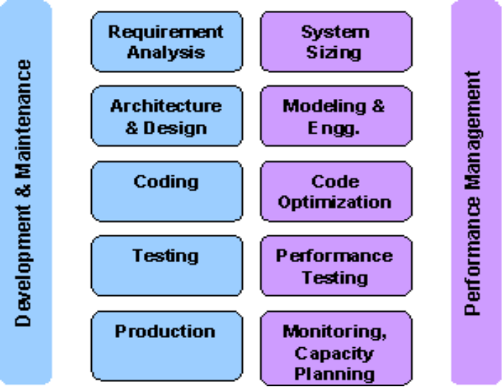
Fig 2.2.2.1 Project Planning and Management Approach

2.2.3 Milestones and Deliverables

Milestones are identified in order to complete the entire project in the time duration. Milestones are identified for every module of our system.

PHASE | DELIVERABLES | PURPOSE
System Requirement and Analysis | - Requirement Gathering and analysis.  - Functional Specifications  - Non Functional Specifications | It gives exact understanding of the user’s requirements.
System Design | - Abstract design  - Requirement for design  - Final Construction  - Designing flow of operation  - Discussing and designing the working | It gives the logical as well as physical structure that describes the system.
Implementation and Testing | The output obtained for the required functionality after implementing and doing various types of testing | It gives the required module

Table 2.2.3.1 Milestones and Deliverables

2.2.4 Roles and Responsibilities

As a system designer and developer we must ensure that the system should fulfil its specification. It should be efficient and consistent. There must not be any anomalies and redundancies in it. Apart from all this it must ensure the security and safety concerns.

Project Team Structure

The Robot project had following team structure:-

Fig 2.2.4.1 Project Team Structure

Project Leader
The responsibilities of the Project Leader are:

- Planning the application customization/development work in the Project.
- Monitoring the day-to-day status of application, system development/customization activities.
- Planning and scheduling of enhancement of system in co-ordination with Team members.
- Ensuring the quality of the deliverables.
- Discussing and giving clarifications necessary to the team members regarding Functionality, system construction etc.
- Manage the flow of work within his/her team and allocate work to team members.
- Monitor the Quality of the deliverables being created.
- Maintain a clarification document and ensure that any change or clarification is reflected in the design documents.

Team member
The responsibilities of a team member include:
- Carrying out the work allocated
- Report on a weekly basis to Project leader.

2.2.5 Group Dependencies

As the entire project was developed by one group there were no group dependencies present.

